

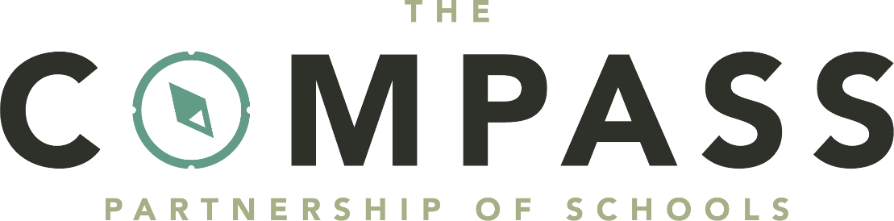
Remote Learning Policy

John Ray Infants School
Monitoring, evaluation and review

This policy will be reviewed and updated if necessary in line with any legislative changes which affect The Compass Partnership of Schools’ practices. Otherwise, this policy will be reviewed every 3 years.

The Local School Committee will assess the implementation and effectiveness of this policy. The policy will be promoted and implemented throughout all Trust schools.

This Policy will be reviewed by the Local School Committee on a three-yearly cycle.

Adherence to the policy will be monitored by the Local School Committee.

Policy adopted: | Spring Term 2026
Other related policies: | Relationships and Behaviour policy  Safeguarding Policy  Data protection policy and privacy notices  Home-school agreement  Acceptable use policy  Online safety policy  Special educational needs policy
Next Review: | Spring Term 2029

Aims
This remote learning policy aims to:
- Ensure consistency in the approach to remote learning for pupils
- Set out how high-quality remote education is provided when it is not possible, or is contrary to government guidance, for some or all pupils to attend school.
- Set out expectations for all members of the school community with regards to remote learning

Use of remote learning
All pupils should attend school, in line with our attendance policy. Remote education is not viewed as an equal alternative to attendance in school and should only be considered as a last resort.
Individual pupils receiving remote education will be marked absent in line with the Pupil Registration Regulations. Where a forced wider school closure occurs, the appropriate Y code will be given.
We will consider providing remote education to pupils in circumstances when in-person attendance is either not possible or contrary to government guidance.
This might include:
- Occasions when we decide that opening our school is either:
  - Not possible to do safely
  - Contradictory to guidance from local or central government
- Occasions when individual pupils, for a limited duration, are unable to physically attend school but are able to continue learning, for example because:
- They have an infectious illness, and are fit and well and able to learn, but can not attend as their infection would pose a risk to others
- They are preparing for or recovering from some types of operation
- They are recovering from injury and attendance in school may inhibit such recovery

The school will consider providing pupils with remote education on a case-by-case basis.
In the limited circumstances when remote learning is used, we will:
- Gain mutual agreement of remote education by the school, parents/carers, pupils, and if appropriate, a relevant medical professional. If the pupil has an education, health and care (EHC) plan or social worker, the local authority (LA) will also be involved in the decision
- Put formal arrangements in place to regularly review it and identify how to reintegrate the pupil back into school
- Identify what other support and flexibilities can be put in place to help reintegrate the pupil back into school at the earliest opportunity
- Set a time limit with an aim that the pupil returns to in-person education with appropriate support

Roles and Responsibilities
Senior leaders are responsible for:
- Co-ordinating the remote learning approach across the school
- Supporting families to overcome any barriers such as access to technology
- Monitoring the effectiveness of remote learning
- Monitoring the security of remote learning systems, including data protection and safeguarding
- Ensuring staff remain trained and confident in their use of online digital education platforms
- Training staff on relevant accessibility features that your chosen digital platform has available
- Providing information to parents/carers and pupils about remote education
- Working with the catering team to ensure pupils eligible for benefits-related free school meals (FSM) are provided with good quality lunch parcels or food vouchers where possible
- Having systems for checking, whether pupils learning remotely are engaging in its use, and work with families to rapidly identify effective solutions where engagement is a concern
Designated safeguarding lead (DSL) is responsible for:
- Ensuring robust systems are in place to check in with parents and children during periods of remote learning

Teachers are responsible for:
- Providing pupils with access to remote education as soon as reasonably practicable, though in proportion to the length of absence and disruption to the learning of all learners
- Ensuring learning provided during periods of remote education is of high quality, meaningful, ambitious and covers an appropriate range of subjects
- Making reasonable adaptations for pupils with SEND
- Considering the needs of pupils’ families or carers, including how much adult involvement is needed in each activity and whether pupils have a suitable place to study
- Providing feedback on learning
- For longer periods of closure, keeping in touch with pupils who are not in school and their parents

How will learning be provided?

Whole school/Cohort closure:
An email will be sent to parents/carers at the earliest possible convenience outlining the learning expected to be undertaken. Learning will be accessed via Google Classroom

Individual periods of school closure:
The class teacher will liaise with parents/carers to arrange appropriate home learning for the pupils.
On approximate daily average learning set:
    - Reception – 2 hours
    - KS1 – 3 hours
    - KS2 – 4 hours
These time scales may be adapted depending on individual needs.
The school will encourage parents/carers to contact them if support is needed to access a device.

Pupils and parents/carers
Staff can expect pupils learning remotely to:
- Complete work to the deadline set by teachers
- Seek help if they need it
- Alert teachers if they’re not able to complete work
- Act in accordance with normal behaviour rules / conduct rules of the school (and any specific online behaviour rules where applicable)
Local governing committee
The governing committee is responsible for:
- Monitoring the school’s approach to providing remote learning to ensure education remains of as high a standard as possible
- Ensuring remote learning systems are appropriately secure for both data protection and safeguarding reasons

Data Protection
- When implementing this policy, Staff will follow information set out in our data protection policy

This policy is linked to our:
- Relationships and Behaviour policy
- Safeguarding Policy
- Data protection policy and privacy notices
- Home-school agreement
- Acceptable use policy
- Online safety policy
- Special educational needs policy

